Dominick Girard  
CSCI 3236 Homework #5

1. **Construct a transition table for M.**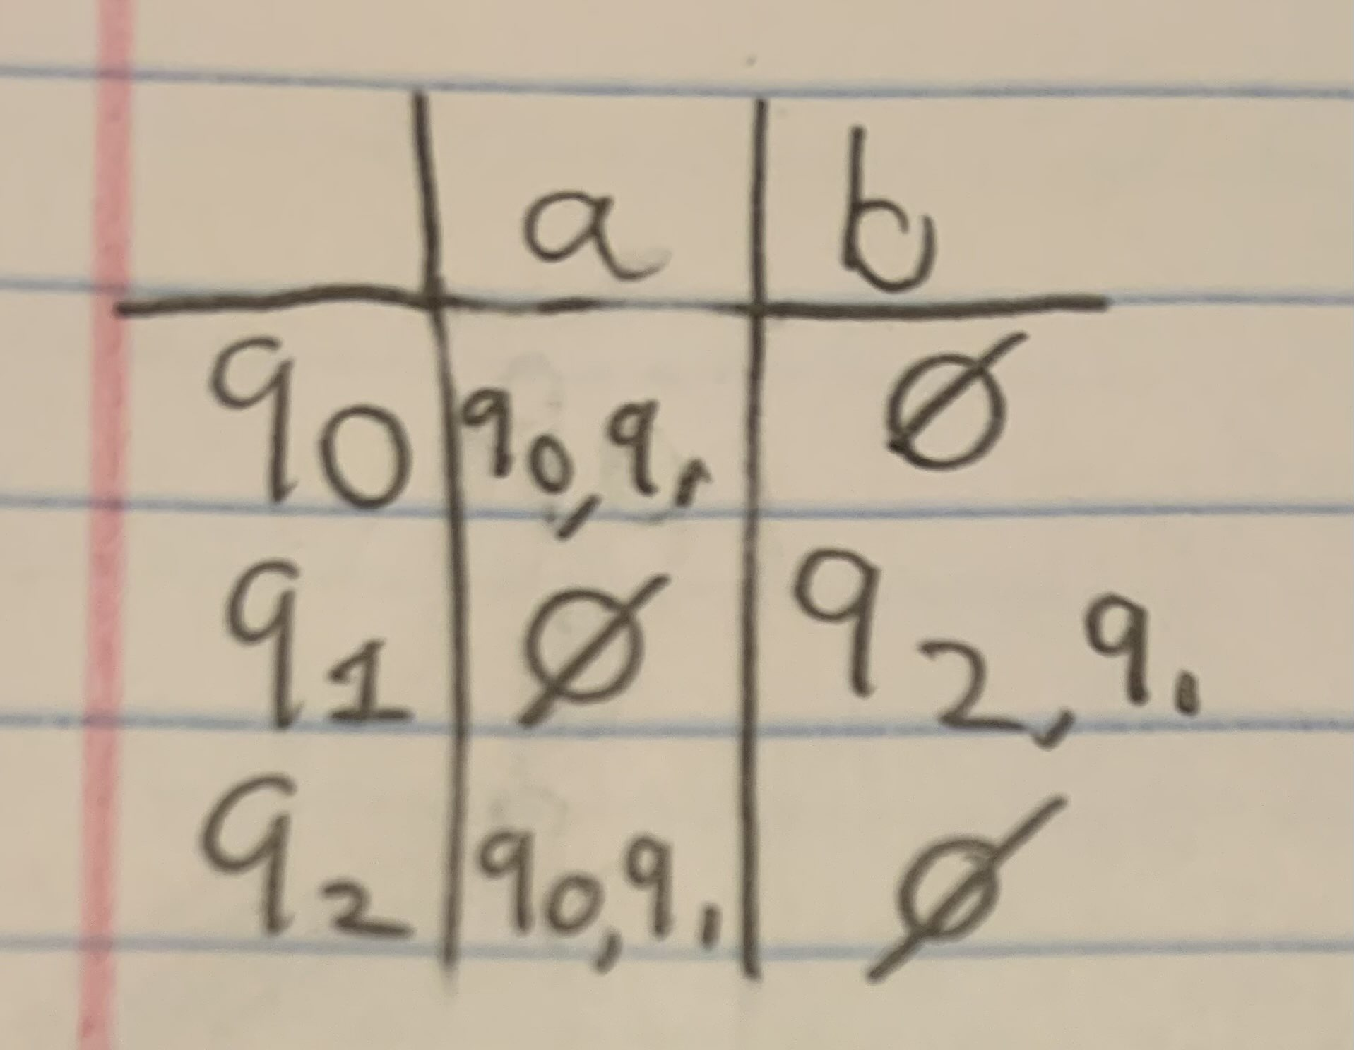
2. **Trace all computations of the string aaabb in M.**

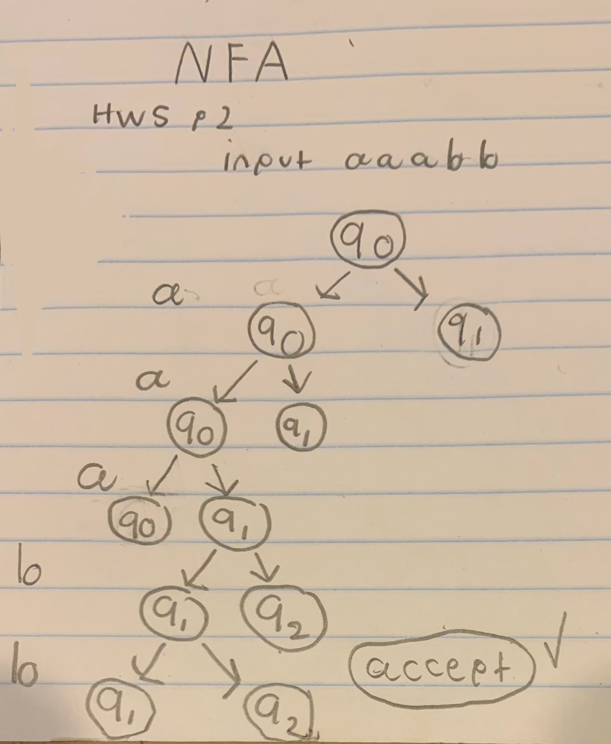

**2) Use the construction given in the video "chapter5 More NFA Lecture" to convert the**

**following NFA to equivalent DFA**

